Report of the Mini Project Done in Partial Fulfilment of the Requirements
Award of
Degree of Bachelor of Technology in Electronics and Communication
Engineering
REAL-TIME TRAFFIC MANAGEMENT SYSTEM
MINI PROJECT REPORT

Done by
Hanna Kurian, Reg No: AJC22EC061
M Shelma, Reg No: AJC22EC080
Nandanakrishna A, Reg No: AJC22EC084
Nithin Anil Kurian, Reg No: AJC22EC087
Under the guidance of
Dr. Therese Yamuna Mahesh
Asst. Professor, Dept of ECE



Bachelor of Technology in
Electronics and Communication Engineering
Department of Electronics & Communication Engineering
Amal Jyothi College of Engineering
(Affiliated to APJ Abdul Kalam Technological University, Thiruvananthapuram)
Kanjirappally – 686518
APRIL – 2025

DEPARTMENT OF ELECTRONICS & COMMUNICATION ENGINEERING
AMAL JYOTHI COLLEGE OF ENGINEERING
(Affiliated to APJ Abdul Kalam Technological University)
Kanjirappally – 686518



BONAFIDE CERTFICATE
This is to certify that the mini project report entitled “Smart Traffic Light System” is a Bonafide report of the Sixth Semester Mini Project [ECD334] done by Hanna Kurian, Reg No: AJC22EC061; M Shelma, Reg No: AJC22EC080; Nandanakrishna A, Reg No: AJC22EC084; Nithin Anil Kurian, Reg No: AJC22EC087 in partial fulfilment of requirements for the award of degree of Bachelor of Technology in Electronics and Communication Engineering from APJ Abdul Kalam Technological University, on July 2025. They have done the mini project with proper approval from the department.

Dr. Therese Yamuna Mahesh Mr. Agi Joseph George
Project Guide Project Coordinator
Professor Asst. Professor

Prof. Geevarghese Titus
Head of the Department

ACKNOWLEDGEMENT

First, we sincerely than the Almighty who is most beneficent and merciful for giving us the knowledge and courage to complete the mini project successfully.
We derive immense pleasure in expressing our sincere thanks to the Principal Dr. Lillykutty Jacob, for her permission and for providing infrastructural facilities for the successful completion of our work of the mini project.
We express our gratitude to Prof. Geevarghese Titus, Head of the Department, ECE, for this encouragement and motivation during our work of the mini project.
We express our heartfelt gratefulness to Dr. Therese Yamuna Mahesh, Professor, Department of ECE, project guide, for her valuable guidance and suggestions during the project.
We also extend our sincere thanks to Mr. Agi Joseph George, Assistant Professor, Department of ECE for his kind support and coordination.
Finally, we appreciate the patience and solid support of our parents and enthusiastic friends for their encouragement and moral support for this effort.

Hanna Kurian
M Shelma
Nanadanakrishna A
Nithin Anil Kurian

ABSTRACT
The Real-Time Traffic Density Management System is designed to optimize traffic signals based on real-time vehicle density and prioritize emergency vehicles. It utilizes an Arduino Mega 2560 as the main controller, an Arduino Nano for additional processing, four HC-SR04 ultrasonic sensors to measure vehicle density, and an RFID RC522 module to detect emergency vehicles. The system dynamically adjusts traffic signal durations using red, green, and orange LEDs, ensuring smoother traffic flow and reduced congestion. When an RFID-tagged emergency vehicle is detected, the system overrides normal signal operations to grant priority passage. Powered by a 12V DC supply, the setup is implemented using a solderless breadboard for easy prototyping. By replacing fixed-timer traffic lights with a real-time adaptive approach, this system improves urban mobility, reduces fuel consumption, and enhances emergency response times. Future advancements could integrate IoT and machine learning to further optimize traffic management efficiency.

TABLE OF CONTENTS
ACKNOWLEDGEMENT………………………………………………i
ABSTRACT…………………………………………………………….ii
LIST OF FIGURES……………………………………………………..iii
LIST OF TABLES………………………………………………………iv
1. INTRODUCTION…………………………………………………….1
2. LITERATURE SURVEY……………………………………………..2
3. REAL-TIME TRAFFIC MANAGEMENT SYSTEM…...…………..6
3.1. System Modelling………………………………………………...6
3.2. Description of System Components……………………………...7
3.2.1. Arduino Mega 2560………………………………………….7
3.2.2. RFID Reader Module…………………………………..........11
3.3. Circuit Diagram…………………………………………………...12
3.4. Cost of materials…………………………………………………..14
4. RESULT………………………………………………………………16
5. CONCLUSION……………………………………………………….18
REFERENCES…………………………………………………………..19
APPENDIX

LIST OF FIGURES
Figure 3.1: Block diagram of proposed system…………………………6
Figure 3.2: Pinout of Arduino Mega 2560………………………………8
Figure 3.3: RFID Reader Module……………………………………….11
Figure 3.4: Circuit Diagram of the Proposed System…………………...12
Figure 4.1: Working Model of the Proposed System……………………

LIST OF TABELS

Tabel 3.1 Cost of Materials……………………………………………...14

CHAPTER 1
INTRODUCTION
Traffic Congestion is a major challenge in urban areas, causing delays, fuel wastage, and environmental pollution. A smart traffic light system aims to improve traffic flow by dynamically adjusting signal timings based on real-time conditions. Unlike traditional systems that operate on the fixed timers, smart traffic lights use advanced technologies such as sensors and RFID modules to enhance efficiency.
Our proposed system employs an Arduino Mega 2560 microcontroller to manage traffic signals based on vehicle density and priority. Ultrasonic sensors are positioned at each lane to detect the number of vehicles present. When a lane experiences high traffic density, the system prioritizes that lane by extending its green signal duration. Additionally, an RFID RC522 module is interconnected to identify emergency vehicles, such as ambulances and fire trucks. Upon detection, the system grants immediately priority to the respective lane, ensuring faster emergency response times.
This smart traffic light system aims to reduce congestion, improve road safety, and enhance overall traffic light management. By incorporating real-time data collection and automated decision-making, the system optimizes signal control, making it a practical solution for modern cities.

CHAPTER 2
LITERATURE SURVEY
[1] Santanu Agarwal , Kumar Anurag , Ramansh Taluja , Prashant Kumar Dewangan, Dr. Manoj H M., 2022, IoT Based Traffic Management System Prioritizing Emergency Vehicles, INTERNATIONAL JOURNAL OF ENGINEERING RESEARCH & TECHNOLOGY (IJERT) Volume 11, Issue 06 (June 2022).
The paper presents a smart traffic management solution using IoT and RFID technology to prioritize emergency vehicles. The system employs RFID tags on emergency vehicles and RFID readers on traffic signal poles to detect approaching emergency vehicles and automatically switch the corresponding signal to green, ensuring minimal delays. An Arduino controller is used to manage the system, with potential integration of cloud-based monitoring for improved control. This approach effectively reduces traffic congestion and enhances road safety, making it relevant for smart traffic management solutions.
[2] R. M.G., D. Krishna, T. R. Shreyas, and Y. Asnath Victory Phamila, "Road Congestion based Traffic Management System with Dynamic Time Quantum," 2018 International Conference on Recent Trends in Advance Computing (ICRTAC), Chennai, India, 2018.
The paper proposes a traffic management system that dynamically adjusts signal timings based on real-time traffic density. The system uses ultrasonic sensors to measure vehicle density at each lane and allocates signal timing accordingly using a dynamic time quantum algorithm. This method ensures optimal signal control by giving longer green light durations to high-density lanes, improving traffic flow, and reducing congestion. The system's adaptive nature makes it effective in handling unpredictable traffic patterns, contributing to efficient urban traffic management.
[3] R. N. Dhole, V. S. Undre, C. R. Solanki and S. R. Pawale, "Smart traffic signal using ultrasonic sensor," 2014 International Conference on Green Computing Communication and Electrical Engineering (ICGCCEE), Coimbatore, India, 2014.
The paper presents a traffic management system that utilizes ultrasonic sensors to detect vehicle density and regulate traffic signals accordingly. The system continuously monitors the number of vehicles in each lane and adjusts the signal timings to reduce congestion. By prioritizing lanes with higher traffic density, the system enhances road efficiency and minimizes waiting time. This approach offers a cost-effective and reliable solution for improving urban traffic control systems.
[4] V. Srinivasan, Y. Priyadharshini Rajesh, S. Yuvaraj and M. Manigandan, "Smart site visitors manipulate with ambulance detection", IOP Conference Series: Materials Science and Engineering, vol. 402, pp. 012015, 2018.
The paper introduces a smart traffic management system designed to prioritize ambulance detection. The system employs RFID technology to identify ambulances and adjust traffic signals accordingly, ensuring they receive a green signal to pass smoothly. This method reduces delays for emergency vehicles and enhances overall traffic efficiency. The proposed solution offers a practical approach to improving emergency response times in urban areas.
[5] Journal, A. Sciences, A. A. Faculty, and E. T. Baniwalid, “Design and Development of Sensor Based Traffic Light System,” Am. J. Appl. Sci., no. August 2014, 2006.
The paper presents a traffic control system that utilizes sensor technology to manage traffic signals efficiently. The system uses sensors to detect vehicle presence and density at intersections, enabling dynamic signal control. By adjusting green light durations based on real-time traffic flow, the system aims to reduce congestion and improve road efficiency. This sensor-based approach offers a practical and effective solution for modern traffic management challenges.
[6] S. Salama, B. K. Saleh, and M. Eassa, “Intelligent cross road traffic management system (ICRTMS),” Computer Technology and Development (ICCTD), 2010 2nd International Conference on. 22/7/2017, pp. 27–31, 2010.
The paper proposes a smart traffic management system designed to control traffic flow at crossroads using intelligent algorithms. The system collects real-time data on vehicle density and adjusts signal timings accordingly to reduce congestion. By employing sensor-based detection and adaptive control techniques, the ICRTMS enhances traffic efficiency, minimizes delays, and ensures smoother vehicle movement. This approach is particularly effective for improving traffic flow in busy urban intersections.
[7] S. Badura and A. Lieskovsky, “Intelligent traffic system: Cooperation of MANET and image processing,” in 2010 First International Conference on Integrated Intelligent Computing Intelligent, 2010, vol. 12, no. 3 A, pp. 119 123.
The paper presents a smart traffic management system that combines Mobile Ad Hoc Networks (MANET) with image processing technology. The system utilizes image processing techniques to analyse real-time traffic conditions and communicate this data through MANET for efficient signal control. This cooperative approach enables better decision-making, improving traffic flow and reducing congestion. The integration of wireless communication and visual data analysis offers a robust solution for modern traffic management systems.
[8] B. J. Saradha, G. Vijayshri and T. Subha, "Intelligent traffic signal control system for ambulances using RFID and cloud," 2017 2nd International Conference on Computing and Communications Technologies (ICCCT), Chennai, 2017, pp. 90-96. doi: 10.1109/ICCCT2.2017.
The paper proposes a smart traffic signal control system designed to prioritize ambulance movement. The system employs RFID technology to identify ambulances and adjusts traffic signals to provide a green corridor for their smooth passage. Additionally, the system leverages cloud technology for real-time data monitoring and control, enhancing scalability and remote access. This approach effectively reduces delays for emergency vehicles and improves overall traffic management in urban areas.
[9] Ksiksi, S. Al Shehhi, and R. Ramzan, “Intelligent Traffic Alert System for Smart Cities,” 2015 IEEE International Conference on Smart City/SocialCom/SustainCom (SmartCity), Dec. 2015.
The paper introduces a smart traffic alert system designed for urban environments. The system leverages IoT sensors and data communication technologies to monitor real-time traffic conditions and provide timely alerts to drivers and traffic control authorities. By analysing traffic patterns and identifying congestion points, the system enhances decision-making for improved traffic flow and reduced delays. This solution is particularly suited for smart city infrastructure, promoting efficient and sustainable urban mobility.

CHAPTER 3
REAL-TIME TRAFFIC MANAGEMENT SYSTEM
3.1 SYSTEM MODELLING
The system modelling of the proposed system is given below:
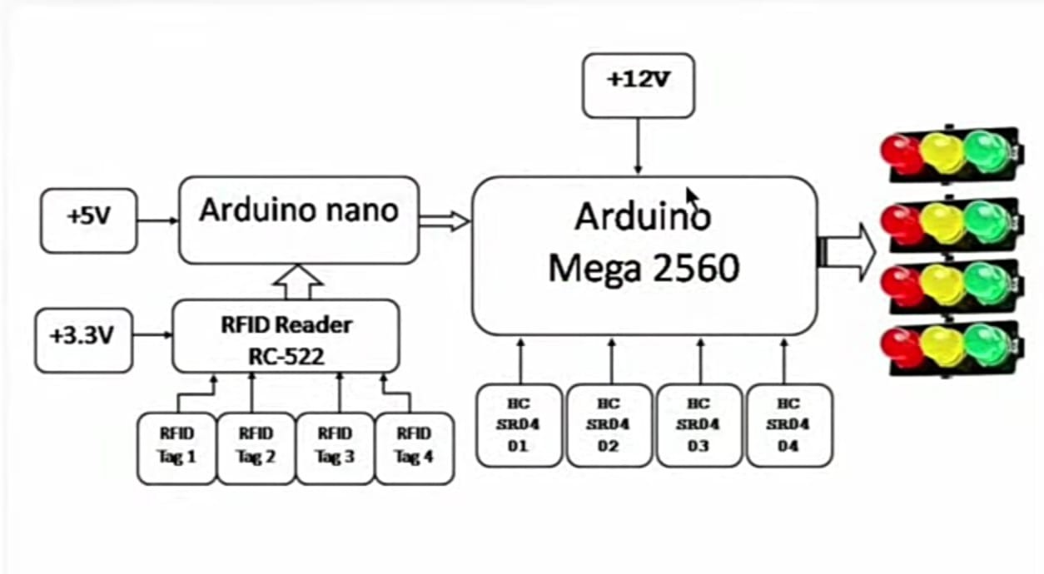
Figure 3.1 Block Diagram of the Proposed System
The block diagram represents a Smart Traffic Control System that combines RFID technology and ultrasonic sensors to efficiently manage traffic flow and prioritize emergency vehicles. The system is powered by +5V, +3.3V, and +12V supplies to operate the components effectively. An Arduino Nano controls the RFID Reader (RC-522), which identifies RFID tags attached to emergency vehicles such as ambulances, fire trucks, or police cars. When a tag is detected, the Arduino Nano sends this information to the Arduino Mega 2560, the central control unit. Simultaneously, HC-SR04 ultrasonic sensors monitor vehicle density in each lane, providing real-time data to the Arduino Mega for dynamic traffic signal adjustments. Based on this data, the system allocates longer green light durations to high-density lanes while prioritizing emergency vehicles by instantly switching the relevant signal to green. This intelligent system enhances traffic flow, minimizes congestion, and ensures quick passage for emergency vehicles, offering an effective solution for modern urban traffic management
3.2 DESCRIPTION OF SYSTEM COMPONETS
3.2.1 ARDUINO MEGA 2560
In a world where innovation drives progress, the Arduino Mega 2560 emerged as a powerful tool for makers, engineers, and hobbyists. Its journey began with the growing need for a microcontroller that could handle complex projects with extensive input and output requirements.
The Arduino Mega 2560 is powered by the ATmega2560 microcontroller, a robust chip designed to manage intricate electronic systems. With its 54 digital I/O pins, 16 analog inputs, and multiple communication interfaces, the Mega 2560 became a game-changer in the field of electronics. This board offers ample space for code storage, featuring 256 KB of Flash memory, 8 KB of SRAM, and 4 KB of EEPROM, allowing users to develop sophisticated programs with ease.
The story of the Mega 2560’s success lies in its versatility. Picture a robotic arm sorting objects on a conveyor belt. With numerous sensors feeding data to the Mega 2560, it swiftly processes information and directs actuators to perform precise movements. In another scenario, an IoT-enabled smart home system relies on the Mega 2560 to gather data from multiple sensors, seamlessly managing lights, fans, and security systems.
The Mega 2560's four hardware serial ports enable communication with multiple devices simultaneously, making it ideal for projects that require extensive data exchange. For instance, in a traffic management system, ultrasonic sensors connected to the Mega 2560 detect vehicle density while an RFID module prioritizes emergency vehicles, ensuring smooth traffic flow. The Mega 2560's ability to interface with Ethernet and Wi-Fi modules further extends its reach, enabling remote monitoring and control.
Programming the Arduino Mega 2560 is straightforward with the Arduino IDE, a user-friendly environment that simplifies coding. Writing a simple LED blinking program or a complex automation system is accessible even to beginners. The IDE’s extensive library support enhances functionality, making it easier to integrate new components.
Despite its capabilities, the Mega 2560 isn’t without limitations. Its larger size may restrict its use in compact spaces, and its power consumption is higher compared to smaller boards like the Arduino Uno. Yet, these drawbacks are outweighed by its powerful features, which enable ambitious projects to become reality.
From creating interactive art installations to building advanced robotics, the Arduino Mega 2560 has empowered innovators across the globe. Its impact is evident in classrooms, research labs, and DIY workshops, proving that with the right tools, imagination can transform into remarkable creations.
Pin Configuration of Arduino Mega 2560
The pin configuration of Arduino Mega 2560 is given below:
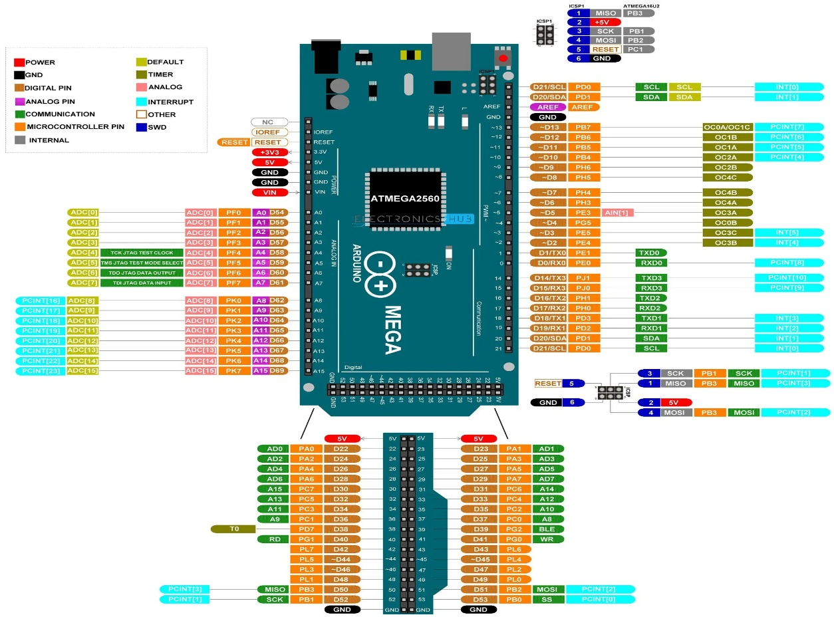
Figure 3.2 Pinout of Arduino Mega 2560
Power Pins
- VIN – Input voltage to the Arduino board when using an external power source (7-12V).
- 5V – Regulated 5V output from the voltage regulator.
- 3.3V – Regulated 3.3V output.
- GND – Ground pins.
- IOREF – Reference voltage for microcontroller.
Digital I/O Pins (D0 to D53)
- Can be configured as INPUT or OUTPUT using pin Mode ().
- Each pin can provide or receive 40mA max.
- Pins D2 to D13 support PWM output (indicated by the tilde ~ symbol).
- Analog Pins (A0 to A15)
- Used for analog input (values between 0 and 1023).
- Each analog pin can also be used as a digital I/O pin.
Communication Pins
- Serial Communication
- TX0 (D1) / RX0 (D0) – UART0
- TX1 (D18) / RX1 (D19) – UART1
- TX2 (D16) / RX2 (D17) – UART2
- TX3 (D14) / RX3 (D15) – UART3
- I2C Communication
- SDA (D20) – Data line
- SCL (D21) – Clock line
- SPI Communication
- MISO (D50) – Master In Slave Out
- MOSI (D51) – Master Out Slave In
- SCK (D52) – Serial Clock
- SS (D53) – Slave Select
- PWM Pins (Pulse Width Modulation)
- Pins 2 to 13, 44 to 46 – Provide PWM output with analog Write ().
Interrupt Pins
- Pins D2, D3, D18, D19, D20, D21 – Can be configured to trigger an interrupt using attach Interrupt ().
Timer Pins
• Timers are linked to specific pins for precise timing operations.
- OC0A (D13)
- OC0B (D4)
- OC1A (D11)
- OC1B (D12)
- OC3A (D5)
- OC3B (D2)
- OC4A (D6)
- OC4B (D7)
- OC5A (D46)
- OC5B (D45)
- OC5C (D44)
- Other Important Pins
- AREF – Reference voltage for the analog-to-digital converter (ADC).
- RESET – Active low reset pin.
Special Pins
- PCINT – Pin Change Interrupt pins (D0–D53).
- SWD – Serial Wire Debug pins for debugging the microcontroller.
3.2.2 RFID CARD READER MODULE
The figure of RFID Reader Module is given below:
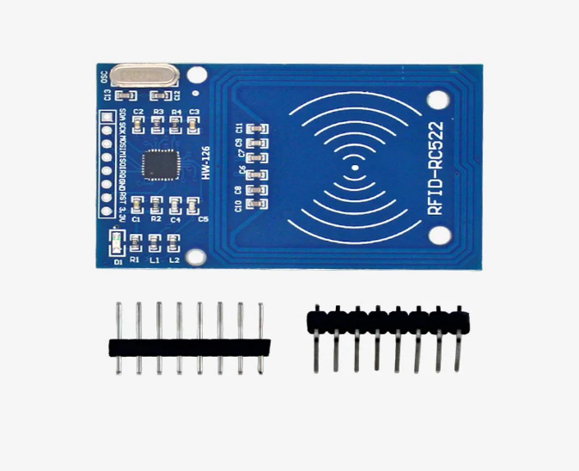
Figure 3.3 RFID Reader Module
An RFID (Radio Frequency Identification) reader module is a device used to read data stored on RFID tags using radio frequency signals. It is widely used in access control systems, inventory management, and automation projects. One commonly used RFID reader is the RC522 module, which operates on a 13.56 MHz frequency and communicates with microcontrollers via SPI(Serial Peripheral Interface), I2C, or UART protocols.
The RC522 module is compact, low-power, and ideal for short-range identification tasks. It features a built-in antenna that enables communication with RFID tags placed within a few centimetres. Each RFID tag has a unique identification number (UID) stored in its memory, which the reader detects and transmits to the connected microcontroller.
In the project, the RC522 module will identify priority vehicles such as ambulances or fire trucks. When an authorized RFID tag is scanned, the system can assign higher priority at the traffic signal, enhancing emergency response efficiency. The RC522 module’s versatility and ease of integration make it suitable for such smart traffic management systems. Proper wiring and code implementation will ensure seamless communication between the RFID reader, Arduino, and other components in your project.
3.3 CIRCUIT DIAGRAM
The circuit diagram of the proposed system is given below:
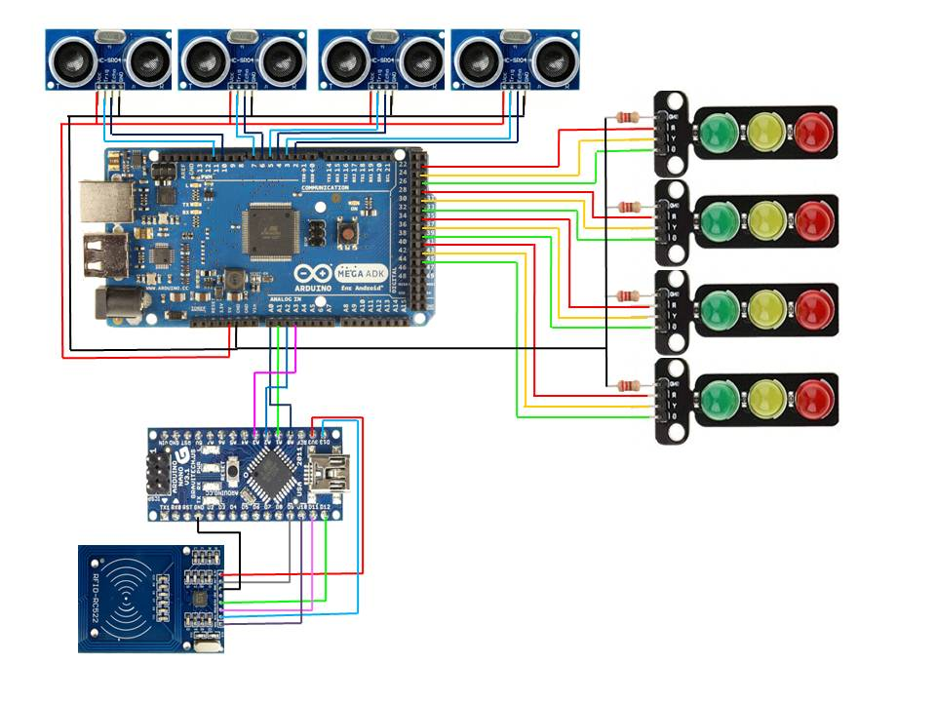
Figure 3.4 Circuit Diagram of Proposed System
The smart traffic light control system efficiently optimizes vehicle flow using Arduino Mega 2560, Arduino Nano, ultrasonic sensors, RFID RC522 modules, and LED signal lights. The system begins by initializing all components, with LED signals defaulting to red to ensure safety. The ultrasonic sensors continuously monitor traffic density in each lane by emitting ultrasonic waves and calculating the time taken for the waves to reflect back after hitting an object, such as a vehicle. Using this data, the system identifies which lane has the highest vehicle density and assigns a longer green light period to that lane, ensuring smoother traffic movement. Lanes with moderate density are given a shorter green period followed by a brief yellow light as a warning, while lanes with low or no density remain on red to reduce unnecessary signal changes. The system dynamically adjusts the duration of each traffic signal based on real-time density data, ensuring optimal traffic control and minimizing delays. In addition to managing vehicle density, the system incorporates an RFID-based priority mechanism for emergency vehicles. The RFID RC522 module detects emergency vehicle tags, immediately prioritizing that lane with a green light while switching all other lanes to red, allowing the emergency vehicle to pass safely and without delay. This override mechanism ensures that emergency vehicles are given maximum priority without manual intervention, enhancing response times during critical situations. Each LED traffic light module is equipped with 220-ohm resistors to prevent current overload and ensure LED longevity. The entire system is powered through a stable 5V/12V DC power supply to maintain consistent voltage across all components, preventing electrical failures. The Arduino Mega handles the primary logic for density calculation, signal timing, and priority management, while the Arduino Nano coordinates RFID data processing and communication. By leveraging this dual-controller setup, the system efficiently manages complex traffic scenarios and enables seamless data flow between components. The traffic light control logic ensures that green lights are assigned to the most congested lanes, while less congested lanes are held at red for optimal efficiency. The system is designed to operate autonomously, continuously monitoring traffic density and adapting the signal timing accordingly. This adaptive nature significantly reduces vehicle idle time, thereby minimizing fuel consumption and reducing pollution. The system's modular design allows for scalability, making it suitable for expanding intersections by adding more ultrasonic sensors, LED signal modules, or RFID readers as needed. The smart traffic light control system also incorporates dynamic timing adjustments to match varying traffic patterns throughout the day, ensuring smooth traffic flow even during peak hours. In addition to improving vehicle movement, this system enhances pedestrian safety by allowing flexible signal timing that can include dedicated pedestrian crossing periods. Future improvements could include integrating IoT features to enable remote monitoring and control, allowing city traffic departments to make real-time adjustments based on sudden traffic surges, accidents, or emergencies. The system can also benefit from AI-based predictive analysis to improve accuracy in traffic density detection and signal timing, further enhancing efficiency. Overall, this intelligent system offers a comprehensive solution for improving road traffic management by dynamically adjusting signals, prioritizing emergency vehicles, and reducing congestion. Its flexible design makes it adaptable to both small intersections and large urban road networks, making it a vital component for smart city infrastructure.

COST OF MATERIALS
Table 3.1 Cost of Materials
SI.NO:  1. | MATERIALS  Solderless Breadboard | COST  100/-
2. | Arduino Mega 2560 | 1700/-
3. | Arduino Nano | 500/-
4. | HC-SR04 Ultrasonic Sensors  (4Nos) | 480/-
5. | RFID READER WRITER MIFARE RC522 | 200/-
6. | RFID TAG/CARD 13.56MHZ | 100/-
7. | ADAP 12V 1AMP | 150/-
8. | JUMPER WIRE FIT | 105/-
9. | 220 Ohm Resistors (4 Nos) | 100/-
10. | Signal Light Module PCB | 273/-
 | Total Cost | 3,708/-

DESCRIPTION OF SIMULATION SOFTWARE
Arduino is an open-source hardware and software platform designed for creating digital devices and interactive projects. It is widely recognized for its user-friendly environment that supports single-board microcontrollers and microcontroller kits. Arduino’s hardware is available under a CC BY-SA license, while its software is distributed under the GNU Lesser General Public License (LGPL) or the GNU General Public License (GPL), allowing both hardware and software to be freely modified and shared. Official Arduino boards and software can be obtained through authorized distributors or the official Arduino website.
Arduino boards are equipped with various microcontrollers and microprocessors that include multiple digital and analog input/output (I/O) pins. These pins facilitate connections with expansion boards, commonly known as “shields,” as well as breadboards used for prototyping electronic circuits. Most Arduino models feature serial communication interfaces, including Universal Serial Bus (USB) ports, which are also utilized for programming and power supply.
The Arduino microcontrollers are programmed using the Arduino programming language, which is derived from C and C++. This language employs a standard API, inspired by the Processing language, ensuring simplicity for beginners while offering flexibility for advanced users. Arduino’s software development environment includes the Arduino IDE, a powerful platform designed to simplify coding, debugging, and uploading programs to Arduino boards. Additionally, Arduino supports command-line tools for more advanced programming needs, ensuring flexibility for developers working in diverse environments.

CHAPTER 4
RESULT
The proposed Smart Traffic Light System was successfully implemented and tested under various traffic conditions. The system dynamically adjusted traffic signal durations based on real-time vehicle density and provided priority clearance for emergency vehicles.
During testing, the system effectively detected traffic congestion and adjusted the green light duration accordingly. Compared to traditional fixed-time traffic signals, the system demonstrated a significant reduction in waiting time and congestion, particularly during peak hours.
The priority mechanism for emergency vehicles was also tested, ensuring immediate clearance when a high-priority vehicle was detected. This feature significantly reduced delays for ambulances and other essential services, enhancing response times and road safety.
The system functioned reliably throughout the testing phase, with smooth transitions between signal states and real-time adjustments to changing traffic conditions. The results indicate that the proposed model can effectively reduce traffic congestion, optimize signal timing, and improve emergency vehicle mobility.
Future enhancements could include machine learning-based predictive traffic control to further optimize traffic flow and IoT integration for real-time data sharing with traffic management systems. These improvements would enhance the system’s adaptability and scalability for smart city applications.
The results confirm that the Smart Traffic Light System is a viable and effective solution for modern traffic management, contributing to safer and more efficient urban transportation.
The results confirm that the Smart Traffic Light System is a viable and effective solution for modern traffic management, contributing to safer and more efficient urban transportation.
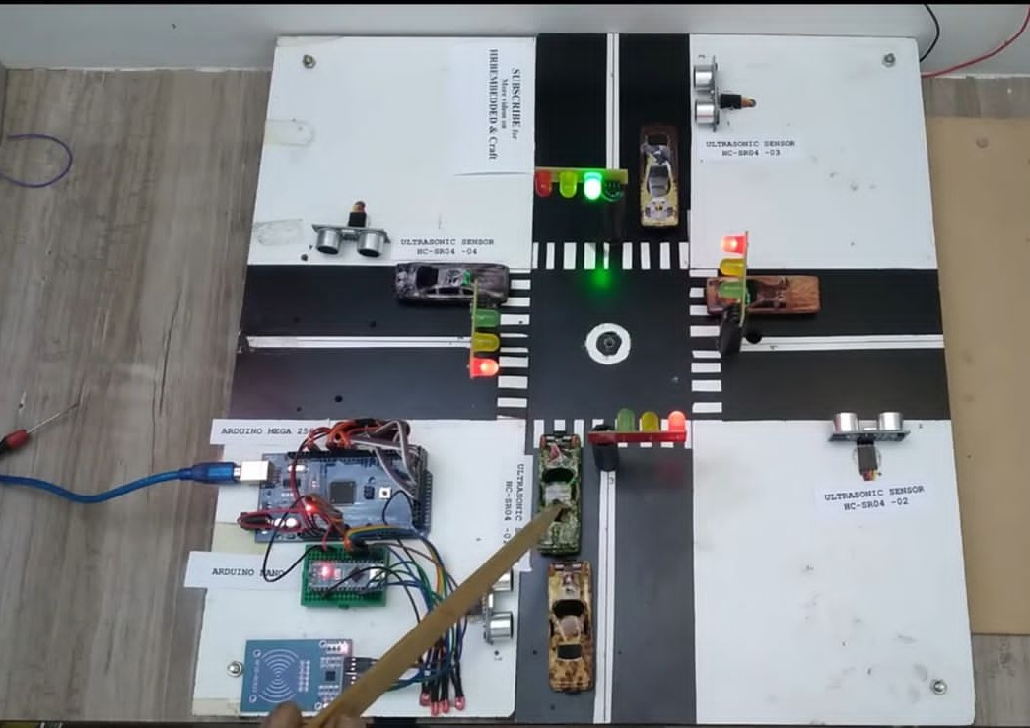
Figure 4.1:Working Model of the Proposed System

CHAPTER 5
CONCLUSION
The Smart Traffic Light System we have designed aims to enhance urban traffic management by incorporating vehicle density monitoring and priority-based control. Traditional traffic signals operate on fixed-time cycles, often leading to unnecessary delays and congestion. Our system overcomes these limitations by dynamically adjusting signal timings based on real-time traffic conditions, improving overall efficiency. The proposed system provides multiple benefits, including reduced congestion, decreased fuel consumption, and improved emergency response times. Unlike traditional traffic lights, which rely on predetermined cycles, our intelligent traffic system adapts dynamically, leading to better traffic flow and enhanced road safety.

REFERENCE
- Santanu Agarwal, Kumar Anurag, Ramansh Taluja, Prashant Kumar Dewangan, Dr. Manoj H M., 2022, IoT Based Traffic Management System Prioritizing Emergency Vehicles, INTERNATIONAL JOURNAL OF ENGINEERING RESEARCH & TECHNOLOGY (IJERT) Volume 11, Issue 06 (June 2022),
- R M G, D. Krishna, T R Shreyas and Y Asnath Victory Phamila, "Road Congestion based Traffic Management System with Dynamic Time Quantum," 2018 International Conference on Recent Trends in Advance Computing (ICRTAC), Chennai, India, 2018, pp. 1-6, doi: 10.1109/ICRTAC.2018.8679287.
- R N Dhole, V. S. Undre, C. R. Solanki and S. R. Pawale, "Smart traffic signal using ultrasonic sensor," 2014 International Conference on Green Computing Communication and Electrical Engineering (ICGCCEE), Coimbatore, India, 2014, pp. 1-4, doi: 10.1109/ICGCCEE.2014.6922284.
- https://www.researchgate.net/publication/325116849_IoT_based_smart_traffic_signal_monitoring_system_using_vehicles_counts
- Rachana K P, Aravind R, Ranjitha M, Spoorthi Jwanita, Soumya K, 2021, IOT Based Smart Traffic Management System, INTERNATIONAL JOURNAL OF ENGINEERING RESEARCH & TECHNOLOGY (IJERT) NCCDS – 2021 (Volume 09 – Issue 12),
- Jounal, A. Sciences, A.A. Faculty, and E T Baniwalid, “Design and Development of Sensor Based Traffic Light System,” Am. J. Appl. Sci., no. August 2014, 2006.
- Salama, B K Saleh, and M Eassa, “Intelligent cross road traffic management system (ICRTMS),” Computer Technology and Development (ICCTD), 2010 2nd International Conference on. 22/7/2017, pp. 27–31, 2010.
- S Badura and A Lieskovsky, “Intelligent traffic system: Cooperation of MANET and image processing,” in 2010 First International Conference on Integrated Intelligent Computing Intelligent, 2010, vol. 12, no. 3 A, pp. 119 123.
- B J Saradha, G. Vijayshri and T. Subha, "Intelligent traffic signal control system for ambulances using RFID and cloud," 2017 2nd International Conference on Computing and Communications Technologies (ICCCT), Chennai, 2017, pp. 90-96. doi: 10.1109/ICCCT2.2017.
- Ksiksi S Al Shehhi, and R. Ramzan, “Intelligent Traffic Alert System for Smart Cities,” 2015 IEEE International Conference on Smart City/SocialCom/SustainCom (SmartCity), Dec. 2015.

APPENDIX

APPENDIX
#include<TimerOne.h>
int signal1[] = {23, 25, 27};
int signal2[] = {29, 31, 33};
int signal3[] = {35, 37, 39};
int signal4[] = {41, 43, 45};
int redDelay = 20000;
int yellowDelay = 2000;
volatile int triggerpin1 = 11;
volatile int echopin1 = 10;
volatile int triggerpin2 = 7;
volatile int echopin2 = 6;
volatile int triggerpin3 = 5;
volatile int echopin3 = 4;
volatile int triggerpin4 = 3;
volatile int echopin4 = 2;
volatile long time; // Variable for storing the time traveled
volatile int S1, S2, S3, S4; // Variables for storing the distance covered
int t = 5; // distance under which it will look for vehicles.
const int button1 = A0;
const int button2 = A1;
const int button3 = A2;
const int button4 = A3;
int button1State = 0;
int button2State = 0;
int button3State = 0;
int button4State = 0;
void setup(){
Serial.begin(115200);
Timer1.initialize(100000); //Begin using the timer. This function must be called first. "microseconds" is the period of time the timer takes.
Timer1.attachInterrupt(softInterr); //Run a function each time the timer period finishes.
pinMode(button1, INPUT);
pinMode(button2, INPUT);
pinMode(button3, INPUT);
pinMode(button4, INPUT);
// Declaring LED pins as output
for(int i=0; i<3; i++){
pinMode(signal1[i], OUTPUT);
pinMode(signal2[i], OUTPUT);
pinMode(signal3[i], OUTPUT);
pinMode(signal4[i], OUTPUT);
}
// Declaring ultrasonic sensor pins as output
pinMode(triggerpin1, OUTPUT);
pinMode(echopin1, INPUT);
pinMode(triggerpin2, OUTPUT);
pinMode(echopin2, INPUT);
pinMode(triggerpin3, OUTPUT);
pinMode(echopin3, INPUT);
pinMode(triggerpin4, OUTPUT);
pinMode(echopin4, INPUT);
}
void loop()
{
button1State = digitalRead(button1);
button2State = digitalRead(button2);
button3State = digitalRead(button3);
button4State = digitalRead(button4);
while (button1State==HIGH)
{
signal1Function();
return 0;
}
while (button2State==HIGH)
{
signal2Function();
return 0;
}
while (button3State==HIGH)
{
signal3Function();
return 0;
}
while (button4State==HIGH)
{
signal4Function();
return 0;
}
while (S1<t) // If there are vehicles at signal 1
{
signal1Function();
}
if (S1>t) // If there are NO vehicles at signal 1
{
signal01Function();
}
while (S2<t) // If there are vehicles at signal 2
{
signal2Function();
}
if (S2>t)
{
signal02Function();
}
while (S3<t) // If there are vehicles at signal 3
{
signal3Function();
}
if (S3>t)
{
signal03Function();
}
// If there are vehicles at signal 4
while (S4<t)
{
signal4Function();
}
// If there are NO BUSY vehicles at signalS
if (S4>t)
{
signal04Function();
}
}
// This is interrupt function and it will run each time the timer period finishes. The timer period is set at 100 milli seconds.
void softInterr()
{
// Reading from first ultrasonic sensor
digitalWrite(triggerpin1, LOW);
delayMicroseconds(2);
digitalWrite(triggerpin1, HIGH);
delayMicroseconds(10);
digitalWrite(triggerpin1, LOW);
time = pulseIn(echopin1, HIGH);
S1= time*0.034/2;
// Reading from second ultrasonic sensor
digitalWrite(triggerpin2, LOW);
delayMicroseconds(2);
digitalWrite(triggerpin2, HIGH);
delayMicroseconds(10);
digitalWrite(triggerpin2, LOW);
time = pulseIn(echopin2, HIGH);
S2= time*0.034/2;
// Reading from third ultrasonic sensor
digitalWrite(triggerpin3, LOW);
delayMicroseconds(2);
digitalWrite(triggerpin3, HIGH);
delayMicroseconds(10);
digitalWrite(triggerpin3, LOW);
time = pulseIn(echopin3, HIGH);
S3= time*0.034/2;
// Reading from fourth ultrasonic sensor
digitalWrite(triggerpin4, LOW);
delayMicroseconds(2);
digitalWrite(triggerpin4, HIGH);
delayMicroseconds(10);
digitalWrite(triggerpin4, LOW);
time = pulseIn(echopin4, HIGH);
S4= time*0.034/2;
// Print distance values on serial monitor for debugging
Serial.print("S1: ");
Serial.print(S1);
Serial.print(" S2: ");
Serial.print(S2);
Serial.print(" S3: ");
Serial.print(S3);
Serial.print(" S4: ");
Serial.println(S4);
}
void signal1Function()
{
Serial.println("1");
low();
// Make RED LED LOW and make Green HIGH for 5 seconds
digitalWrite(signal1[0], LOW);
digitalWrite(signal1[2], HIGH);
delay(redDelay);
// if there are vehicels at other signals
if(S2<t || S3<t || S4<t)
{
// Make Green LED LOW and make yellow LED HIGH for 2 seconds
digitalWrite(signal1[2], LOW);
digitalWrite(signal1[1], HIGH);
delay(yellowDelay);
}
}
void signal2Function()
{
Serial.println("2");
low();
digitalWrite(signal2[0], LOW);
digitalWrite(signal2[2], HIGH);
delay(redDelay);
if(S1<t || S3<t || S4<t)
{
digitalWrite(signal2[2], LOW);
digitalWrite(signal2[1], HIGH);
delay(yellowDelay);
}
}
void signal3Function()
{
Serial.println("3");
low();
digitalWrite(signal3[0], LOW);
digitalWrite(signal3[2], HIGH);
delay(redDelay);
if(S1<t || S2<t || S4<t)
{
digitalWrite(signal3[2], LOW);
digitalWrite(signal3[1], HIGH);
delay(yellowDelay);
}
}
void signal4Function()
{
Serial.println("4");
low();
digitalWrite(signal4[0], LOW);
digitalWrite(signal4[2], HIGH);
delay(redDelay);
if(S1<t || S2<t || S3<t)
{
digitalWrite(signal4[2], LOW);
digitalWrite(signal4[1], HIGH);
delay(yellowDelay);
}
}
void signal01Function()
{
Serial.println("01");
low();
digitalWrite(signal1[0], LOW);
digitalWrite(signal1[2], HIGH);
delay(3000);
digitalWrite(signal1[2], LOW);
digitalWrite(signal1[1], HIGH);
delay(1000);
digitalWrite(signal1[1], LOW);
digitalWrite(signal1[0], HIGH);
}
void signal02Function()
{
Serial.println("02");
low();
digitalWrite(signal2[0], LOW);
digitalWrite(signal2[2], HIGH);
delay(3000);
digitalWrite(signal2[2], LOW);
digitalWrite(signal2[1], HIGH);
delay(1000);
digitalWrite(signal2[1], LOW);
digitalWrite(signal2[0], HIGH);
}
void signal03Function()
{
Serial.println("03");
low();
digitalWrite(signal3[0], LOW);
digitalWrite(signal3[2], HIGH);
delay(3000);
digitalWrite(signal3[2], LOW);
digitalWrite(signal3[1], HIGH);
delay(1000);
digitalWrite(signal3[1], LOW);
digitalWrite(signal3[0], HIGH);
}
void signal04Function()
{
Serial.println("04");
low();
digitalWrite(signal4[0], LOW);
digitalWrite(signal4[2], HIGH);
delay(3000);
digitalWrite(signal4[2], LOW);
digitalWrite(signal4[1], HIGH);
delay(1000);
digitalWrite(signal4[1], LOW);
digitalWrite(signal4[0], HIGH);
}
// Function to make all LED's LOW except RED one's.
void low()
{
for(int i=1; i<3; i++)
{
digitalWrite(signal1[i], LOW);
digitalWrite(signal2[i], LOW);
digitalWrite(signal3[i], LOW);
digitalWrite(signal4[i], LOW);
}
for(int i=0; i<1; i++)
{
digitalWrite(signal1[i], HIGH);
digitalWrite(signal2[i], HIGH);
digitalWrite(signal3[i], HIGH);
digitalWrite(signal4[i], HIGH);
}
}

